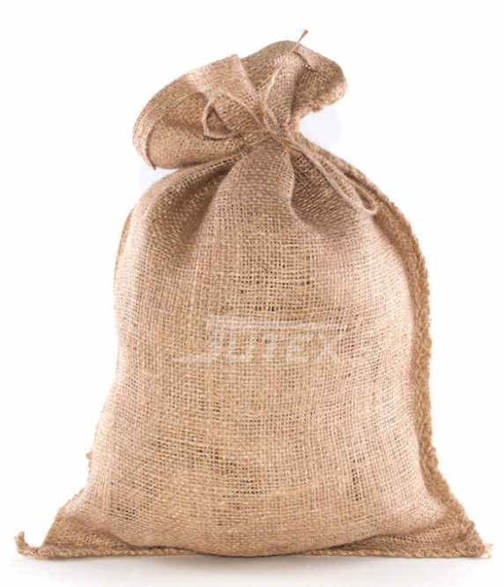  i | k
m | s
p | aa
r | e
v | n
t | ee
b | oo
d | oe
z | ij
h | w
o | a
u | j
eu | ie
l

